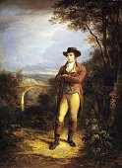

**The Scottish Society of Middle Tennessee**

**Invites you to Attend the**

**Annual Burns Supper**

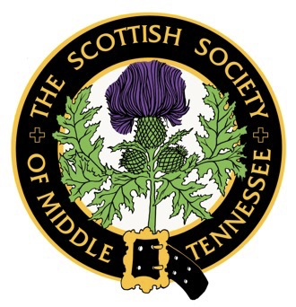

**Annual Burns Supper**

**Saturday, January 25, 2025**

Cash Bar Reception – 5:00pm -5:30pm

Highland Dancing 5:30pm

Piped into Dinner – 6:00pm

Brentwood Country Club

5123 Country Club Drive

Brentwood, TN 37027

$110.00 PP member - 160.00 PP non-member

RSVP by January 15, 2024 to

arlynmidtnscots@gmail.com

Please include names and meal requests.

*Choices are Filet Beef – Salmon – Vegetarian*

Payment by PayPal or credit card on the website midtnscots.org/events or by check to

SSMT PO BOX 2914 Brentwood, TN 37024

Update dues at midtnscots.org/membership or mail

*Black Tie/Highland Dress